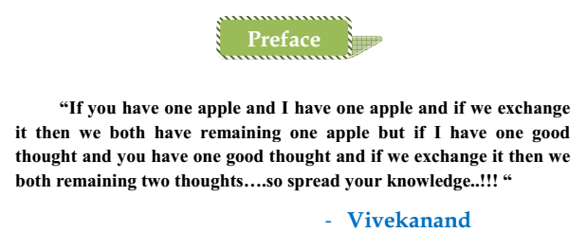

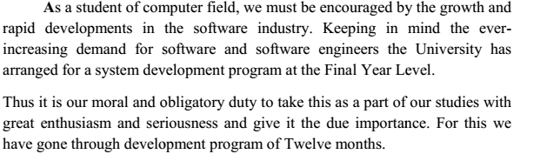 **With great pleasure we undertake the writing of document for** **“School Management System (WEB Based)” because it is a fact to proud of that we are the student undertaking education in field of Computer Science & Engineering and Computer Science & Information Technology which is being offered at graduation level in Shanto-Mariam University of Creative Technology.**